# **MINI PROJECT REPORT**

on

## **Smart Traffic Management System Using IOT**

Submitted in partial fulfillment of requirements to

**CB 352 Mini Project**

**III/IV B. Tech CSBS (V Semester)**

By

Y21CB032 – RAMTEJ MALLIPUDI

Y21CB029 – HYENDAVI BAI KSHATRIYA

Y21CB014 – JAHNAVI GUMMA



**2023-2024**

# **Department of Computer Science and Business Systems**

**R.V.R & J.C. COLLEGE OF ENGINEERING**

#### **(AUTONOMOUS)**

**(Approved by A.I.C.T.E) NAAC ‘A+’ Grade (Affiliated to Acharya Nagarjuna University) Chandramoulipuram: Chowdavaram**

**GUNTUR – 522 019**

# **R.V.R & J.C. COLLEGE OF ENGINEERING**

### DEPARTMENT OF

COMPUTER SCIENCE & BUSINESS SYSTEMS



#### **BONAFIDE CERTIFICATE**

This is to Certify that this Mini Project work entitled **“Smart Traffic Management System Using IOT”** is the bonafide work of **Ramtej Mallipudi (Y21CB032), Hyendavi Bai Kshatriya (Y21CB029), Jahnavi Gumma (Y21CB014)** of **III/IV B.Tech** who carried the work under my supervision, and submitted in the partial fulfilment of the requirements to **CB352 - MINI PROJECT LAB REPORT** during the year 2023-2024.

|  |  |  |
| --- | --- | --- |
| **Dr. Ch. Sudha Sree** | **Mr. P. Srinivasa Rao** | **Dr. M. V. P. Chandra Sekhara Rao** |
| (Project Guide) | (Project Incharge) | Prof. & Head, Dept. of CSBS. |

# **ACKNOWLEDGEMENTS**

From the idea to the act, from the conception to reality, from the emotion to the response, from the desire to the spasm, we are led by those about whom to write all words seem meek.

We are very much thankful to **Dr. Kolla. Srinivas, Principal of R.V.R. & J.C College of Engineering**, Guntur, for allowing us to work on this project.

We express our sincere thanks to **Dr. M.V.P. Chandra Sekhara Rao, Professor and Head, Department of Computer Science and Business Systems** for encouraging and supporting us to carry out this project successfully.

We are very glad to express our special thanks to **Dr. Ch. Sudha Sree, Project guide** who has inspired us to select this project according to our choice and for her valuable advice to work on this project.

This Mini Project wouldn’t be completed without the help of my friends, family members and other people who are directly or indirectly connected with this work. I also express my sincere thanks to the **Technical** and **Non-Technical staff** and **all the faculty of the department** for their valuable help.

RAMTEJ MALLIPUDI (Y21CB032) HYENDAVI BAI KSHATRIYA (Y21CB029) JAHNAVI GUMMA (Y21CB014)

**ABSTRACT**

Traffic congestion is a major problem in many cities of India along with other countries. Failure of signals, poor law enforcement and bad traffic management are major reasons. With the rapid growth of population in metropolitan cities, traffic congestion is often seen. Traffic congestion has a negative impact on economy, the environment and the overall quality of life. Hence it is high time to effectively manage the traffic congestion problem. There are various methods available for traffic congestion management. In order to resolve this issue, a smart traffic management system using Internet of Things (IOT) is introduced. This technology can act as a key to smart traffic management in real time. This new technology which will require less time for installation with lesser costs as compared to other methods of traffic congestion management. Use of this new technology with the suitable algorithm will lead to reduce and manage traffic congestion efficiently. For this purpose, the system takes the density of traffic as an input from cameras, sensors and manages traffic signals. Another algorithm based on Artificial Intelligence is used to predict the traffic density for future to minimize the traffic flow on roads. To demonstrate the effectiveness of this hybrid traffic management system, a prototype is developed which not only optimizes the flow of traffic but also contacts nearby rescue departments with a centralized server. Moreover, it also extracts useful information presented in graphical formats that may help the authorities in future road planning.

#### 

**CONTENTS**

**Chapter No. & Name Page No.**

Abstract ii

List of figures iv

1.Introduction 1

2.Existing Methodology 2

2.1 Inductive loop detection

2.2 Video analysis

2.3 Infrared sensors

3.Proposed System 3

3.1 Data Acquisition & Collection Layer

3.2 Data Processing & Decision Making Layer

3.3 Application & Actuation Layer

4.Components used 7

5.UML diagrams 8

6.Applications 11

7.Implementation 12

8.Results & discussion 19

9.Conclusion & future work 22

References 23

#### **LIST OF FIGURES**

**Fig No. & Name Page No.**

3.1. The system model 3

3.2. Sensor networks 4

3.3. Flow chart of traffic management system 5

3.4. Blue print of traffic management system 6

5.1. Use case diagram 8

5.2. Activity diagram 9

5.3. Class diagram 10

8.1. Traffic statistics 21

**1. INTRODUCTION**

Traffic congestion on road networks is nothing but slower speeds, increased trip time and increased queuing/jam of the vehicles. When the number of vehicles moving on road exceeds the capacity of the road, the issue of traffic congestion occurs. In the metropolitan cities of India traffic congestion is a major problem. Traffic congestion is caused when the demand exceeds the available capacity of road. This is known as Saturation. Individual incidents such as accidents or sudden braking of a car in a smooth flow of heavy traffic have adverse effects and are main cause of traffic jams. There are even severe security problems in traffic system due to anti-social elements which also leads to block of traffic at one place.

A city consists of many interdependent subsystems where traffic system is one of its important one. An article says; traffic management is the cornerstone of the world’s economy. Moreover, it is also considered as one of the major dimensions of the smart city. With the rapid growth of the world’s population, the number of vehicles on roadways are increasing subsequently, also the rate of traffic congestion is increasing in the same manner. In country like India, there is an annual loss of Rs 60,000 crores due to congestion (including fuel wastage). Congestion in India has also led to slow speeds of freight vehicles, and increased waiting time at checkpoints and toll plazas. The average speed of vehicles on key corridors like Mumbai-Chennai, Delhi-Chennai is less than 20kmph, while it is mere 21.35kmph on Delhi-Mumbai stretch. As per the transport corporation of India and IIM, India’s freight volume is increasing annually. Traffic jams are not only just wasting citizen’s time but also witnessed some criminal activities like mobile snatching at traffic signals which also happen in metropolitan cities. On the other hand, it is not only affecting the ecosystem badly but on the other hand industry’s efficiency is also being affected. It is, therefore, identified that there is a necessity of active traffic management.

In majority countries, traffic is managed through fixed time signals whereas, in large cities of some developed countries, traffic is managed through centrally controlled systems. Internet of Thing (IoT) has been introduced to improve efficiency in traffic management systems. To the best of our knowledge, it is identified that till date the current traffic management systems are centralized. System’s servers may crash in case of network issues. In addition, there is less focus on fluctuations in traffic flow. Therefore, the proposed system manages the traffic on local and centralized servers by applying the concepts of IoT and Artificial Intelligence together. The representation of traffic data in statistical form can also be helpful to authorities for real-time controlling and managing traffic. Moreover, it may also be helpful for future planning.

**2. EXISTING METHODOLOGY**

Existing traffic system follows various methods like inductive loop detection, video analysis, infrared sensors etc. Which consumes more time for installation and also costs high. Apart from this there are some drawbacks in this system. Below shows the existing methodology and drawbacks of existing system.

**2.1 Inductive Loop Detection**

Inductive loop detection works on the principle of one or more turns of insulated wire are placed in a shallow cutout in the roadway, a lead in wire runs from roadside pull box to the controller and to the electronic unit located in the controller cabinet. When a vehicle passes over the loop or stops, the induction of the wire is changed. Due to change in induction, there is change in the frequency. This change in the frequency causes the electronic unit to send a signal to the controller; indicating presence of the vehicle. Inductive loop detection is useful in knowing the vehicle presence, passage, occupancy and even the number of vehicles passing through a particular area. But there are few problems with this system. These include poor reliability due to improper connections made in the pull boxes and due to application of sealant over the cutout of the road. If this system is implemented in poor pavement or where the digging of the roads is frequent then there is a problem of reliability.

**2.2 Video Analysis**

Video analysis consists of a smart camera placed which consists of sensors, a processing unit and a communication unit. The traffic is continuously monitored using a smart camera. The video captured is then compressed so as to reduce the transmission bandwidth. The video analysis abstracts scene description from the raw video data. This description is then used to compute traffic statistics. This statistic includes frequency of the vehicles, average speed of the vehicles as well as the lane occupancy. The problems associated with video analysis are – (a) the overall cost of the system is quite high (b) the system gets affected in case of heavy fog or rains (c) night time surveillance requires proper street lighting.

**2.3 Infrared Sensors**

Infrared sensors are used to detect energy emitted from vehicles, road surfaces and other objects. The energy captured by these infrared sensors is focused onto an infrared sensitive material using an optical system which then converts the energy into the electric signals. These signals are mounted overhead to view the traffic. Infrared sensors are used for signal control, detection of pedestrians in crosswalks and transmission of traffic information. The basic disadvantages of infrared sensors are that the operation of the system may be affected due to fog; and also installation and maintenance of the system is complicated.

**3. PROPOSED SYSTEM**

The proposed system, shown below in Figure 1, is designed to manage traffic at road networks, sensing through sensors, surveillance cameras, and RFIDs which are installed on roadsides. The system works in a distributed manner, such that it processes sensor’s data at the node level and video’s data at the local server, calculates the total density to regulate the traffic according to density. In addition to this, it also contacts emergency vehicles such as ambulance, fire brigade. It also helps the users to know the congestion status of a road. The system is divided into three layers. A) Data Acquisition and Collection layer. B) Data Processing and Decision-making layer C) Application and Actuation layer.

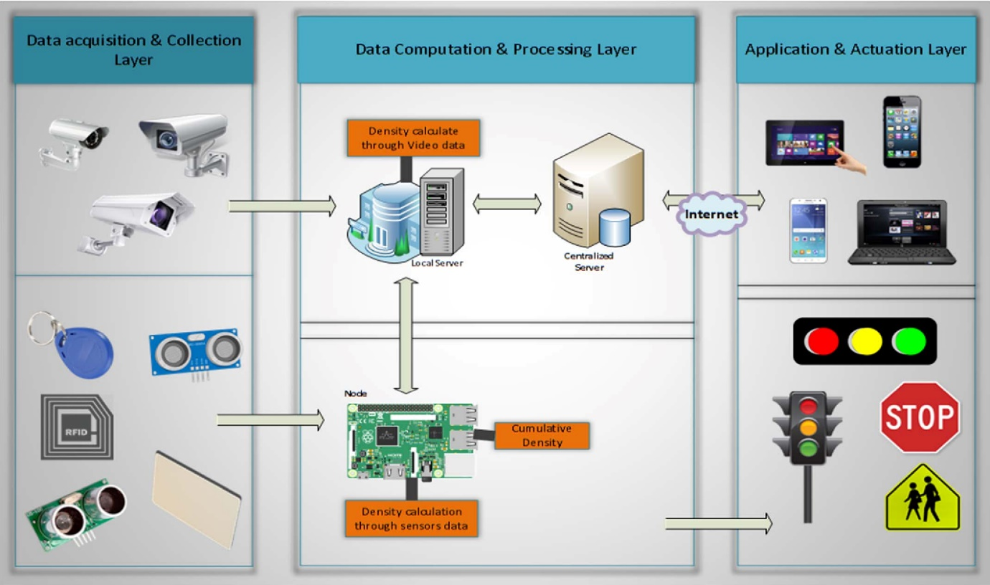

**Figure 3.1**. *The System Model*

**3.1. Data Acquisition and Collection Layer**

Several ways of traffic detection have been used in this layer which consists ultrasonic sensors, RFIDs, surveillance cameras and light beam. All these sources have merits as well as demerits; the suitable sources in view of the proposed system are surveillance cameras, ultrasonic sensors and RFIDs. A surveillance camera is the most widely used source to detect the road traffic in this field due to efficiency and the ease of maintenance. A special algorithm is applied to the video stream at the local server due to its performance and capability of noise reduction. After traffic detection, local server sends the density measured to the respective microcontroller through image processing. This system also uses ultrasonic sensors to enhance the accuracy. In many traffic management systems, Sensors are integral part used to detect traffic density.

**3.2. Data Processing and Decision-Making Layer**

The system manages the road traffic according to the traffic condition. a) In the first case, each traffic signal has a fixed time that is x seconds, when there is normal traffic on road. Every signal is going to turn green at their turn for x seconds, and rest of signals at that time remains red until all remaining traffic signals complete their turn. Traffic ratio is increasing day by day and our current Fixed-time signal control system is not working. In this situation, there is a need to add a density-based traffic management module which allocates time dynamically to each lane based on the traffic density, in second part of algorithm when the capacity of traffic is increased and flow of traffic is not in routine, the system calculates the level of density and update the time ȕ of traffic signal on the basis of traffic density. Further, undergoes to traffic management algorithm as discussed.

**3.3. Application and Actuation Layer**

In this layer, two types of information are delivered a) duration of a green signal from node to traffic signal and ii) daily, weekly, monthly and yearly reports of smart traffic management system through the web application from a centralized server. First of all, the system calculates rush interval by using Regression Tree algorithm. This report is then displayed on the web application which is linked to a centralized server which is for the administration of smart traffic management system, that shows daily, weekly, monthly and yearly graphs of rush intervals. This graphical information is useful for the future road planning and resource management. After receiving the rush interval intimation, the decision-making module updates the duration of the green signal to the respective traffic signal. In this modern era, where time is money, there is a need to know the traffic condition on the particular road by using mobile application. Moreover, this system is also capable of managing emergency situations like if the smoke and fire are detected on the road.

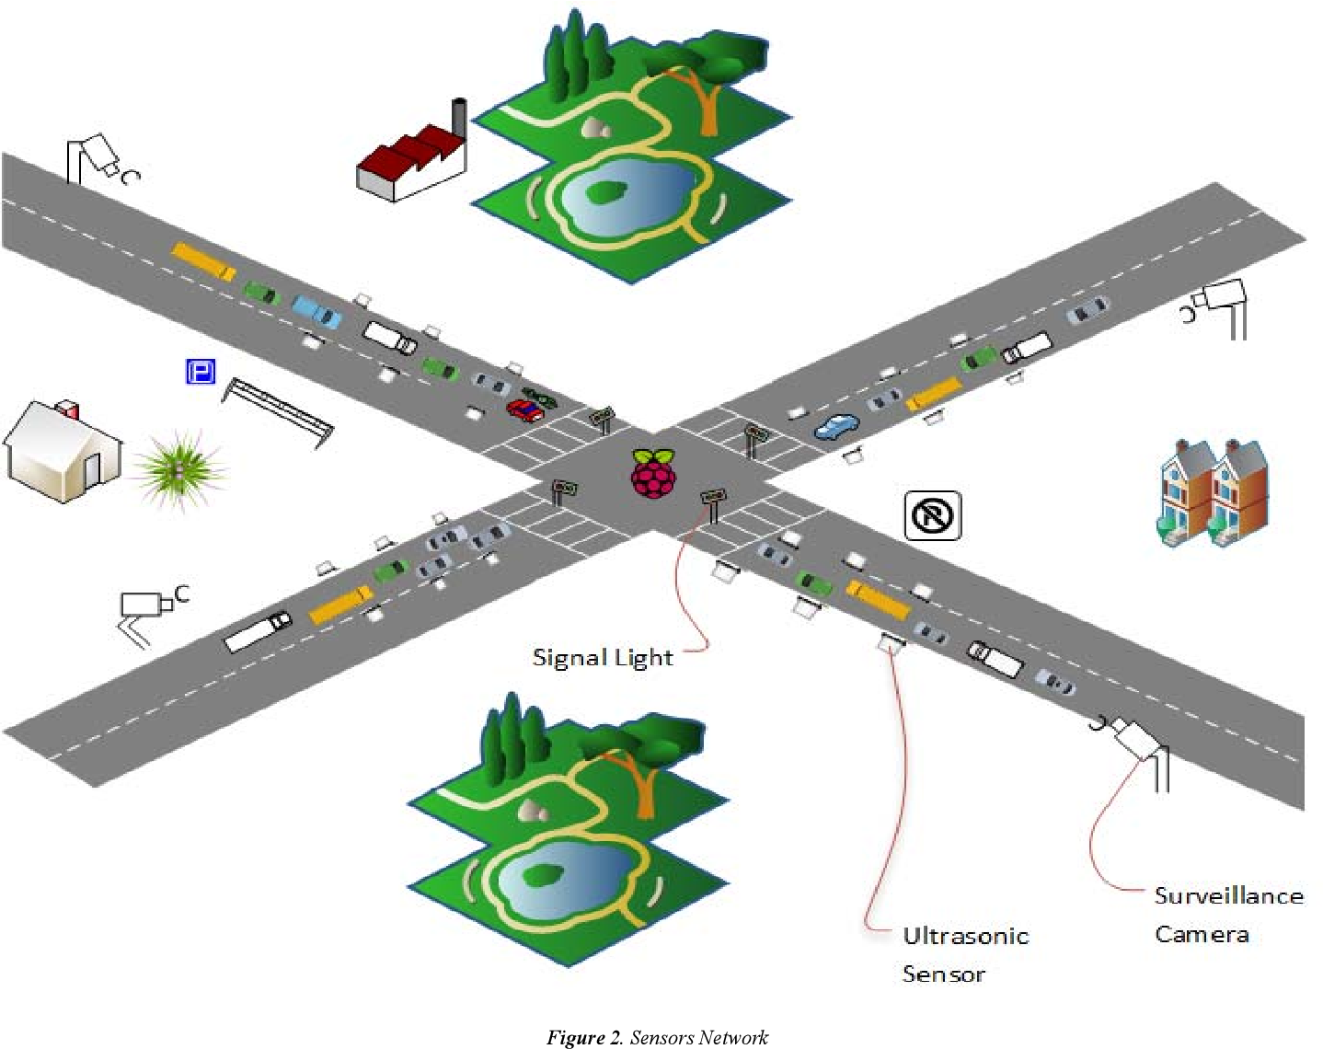

**Figure 3.2.** *Sensor networks*

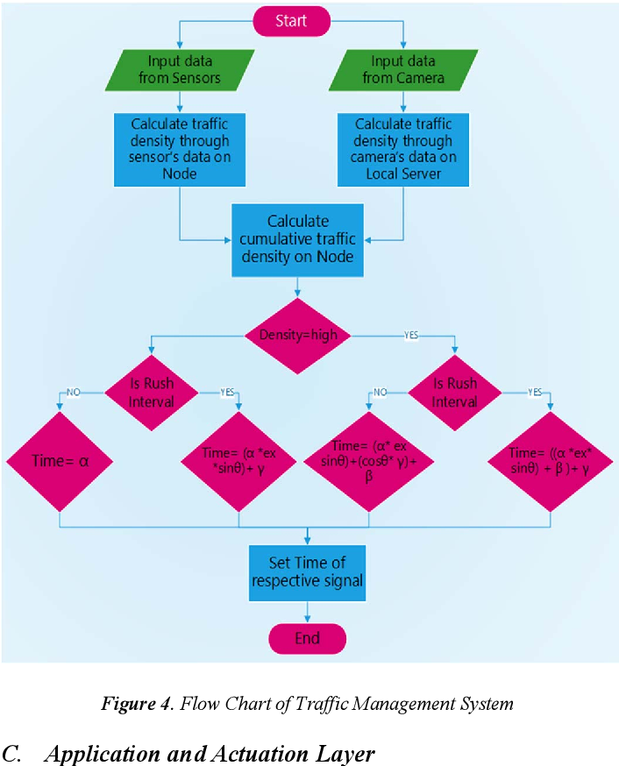**Figure 3.3.** *Flow chart of traffic management system*

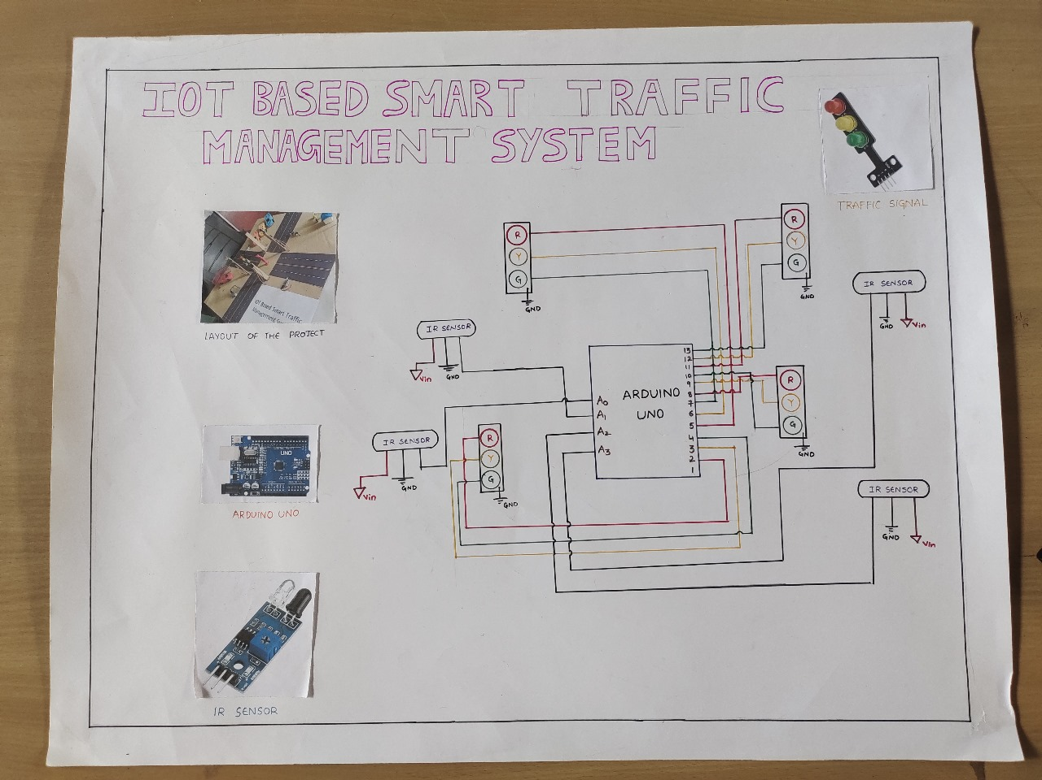

**Figure 3.4.** *Blue print of traffic management system*

**Procedure:**

1.Take an Arduino board, IR sensors, traffic signal lights module.

2.Connect OUT pin of IR sensor to A0 of Arduino board.

3.Next connect Red LED of traffic signal module to pin no.2 in Arduino board.

4.Connect Yellow LED of traffic signal module to pin no.3 in Arduino board.

5.Connect Green LED of traffic signal module to pin no.4 in Arduino.

6.Repeat from step 2-5 for the remaining three traffic signal modules to required pins of Arduino board.

**4. COMPONENTS USED**

**Arduino board:**

Arduino refers to an open-source electronics platform and a family of microcontroller boards designed for various purposes, such as prototyping and creating interactive electronic projects. The Arduino boards are equipped with input and output pins that allow them to connect to a variety of sensors, actuators, and other electronic components. They can be programmed using the Arduino programming language, which is a simplified version of C/C++, through the Arduino Integrated Development Environment (IDE).

Arduino boards are widely used by hobbyists, students, and professionals to create projects ranging from simple LED displays to more complex systems involving robotics, home automation, and Internet of Things (IoT) applications. The open-source nature of Arduino means that the hardware specifications and software are freely available, fostering a large and active community of developers who contribute to its growth and improvement.

**IR sensors:**

IR sensors, or infrared sensors, are devices that can detect and measure infrared radiation in their surroundings. Infrared radiation is a type of electromagnetic radiation with wavelengths longer than those of visible light, making it invisible to the human eye. IR sensors are commonly used in various applications for proximity sensing, object detection, and temperature measurement.

IR sensors find applications in a wide range of fields, including automation, robotics, security systems, medical devices, and more. Their ability to detect infrared radiation makes them valuable for tasks where traditional visible light sensors may not be suitable.

**Traffic signal module:**

In the context of the Internet of Things (IoT), a traffic signal module refers to a connected device or system that manages and controls traffic signals using IoT technologies. The goal is to enhance the efficiency, safety, and overall management of traffic flow in urban areas. IoT-enabled traffic signal modules often incorporate various sensors to gather real-time data about the traffic conditions. Traffic signal modules in an IoT system can be remotely monitored and controlled through a centralized management platform. This allows traffic engineers and authorities to adjust signal timings, respond to changing traffic conditions, and optimize overall traffic flow.

By leveraging IoT technologies in traffic signal management, cities can achieve more intelligent and responsive control over their traffic systems. This can lead to reduced congestion, improved safety, and better overall urban mobility.

**5. UML DIAGRAMS**

**Use case diagram:**

A use case diagram is a type of diagram in the Unified Modelling Language (UML) that is used to visually represent the interactions between various actors (individuals or entities external to the system) and a system under consideration. The primary purpose of a use case diagram is to show the functionalities or features provided by a system from the perspective of its users. Use case diagrams are useful during the early stages of system development for capturing and communicating the system's functionality from a user's perspective. They provide a high-level view of the system's behaviour and are particularly helpful in understanding the ways in which users interact with the system to achieve their goals. Additionally, use case diagrams can serve as a foundation for more detailed modelling and documentation throughout the software development life cycle.

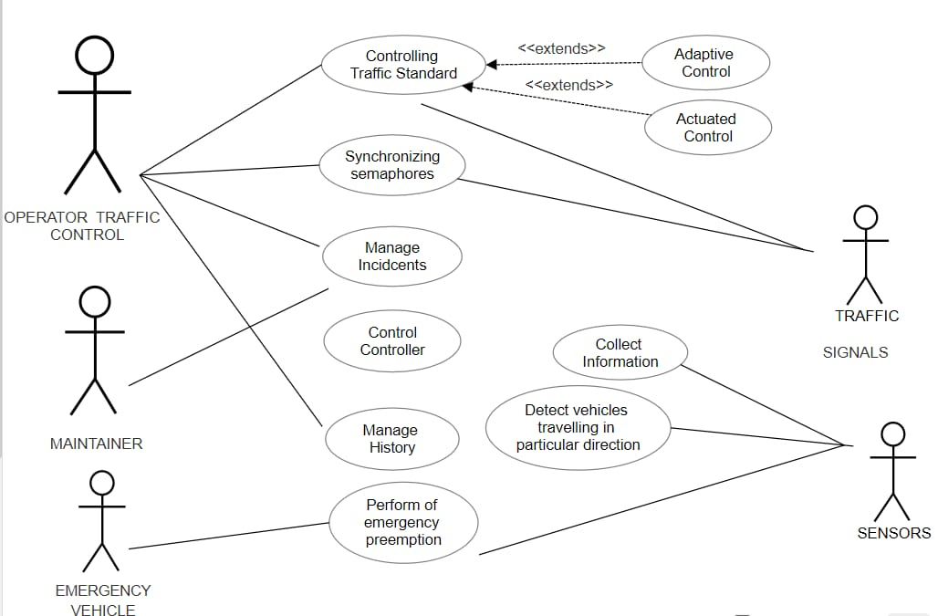

**Activity diagram:**

An activity diagram is a type of UML (Unified Modelling Language) diagram that illustrates the flow of activities within a system or a business process. It is a dynamic diagram that focuses on the sequence and conditions of various activities, showing how different elements of a system or process interact over time.

Creating a complete activity diagram for a Smart Traffic Management System involves understanding the specific activities, interactions, and processes within the system. Below is a simplified example of an activity diagram for a Smart Traffic Management System.

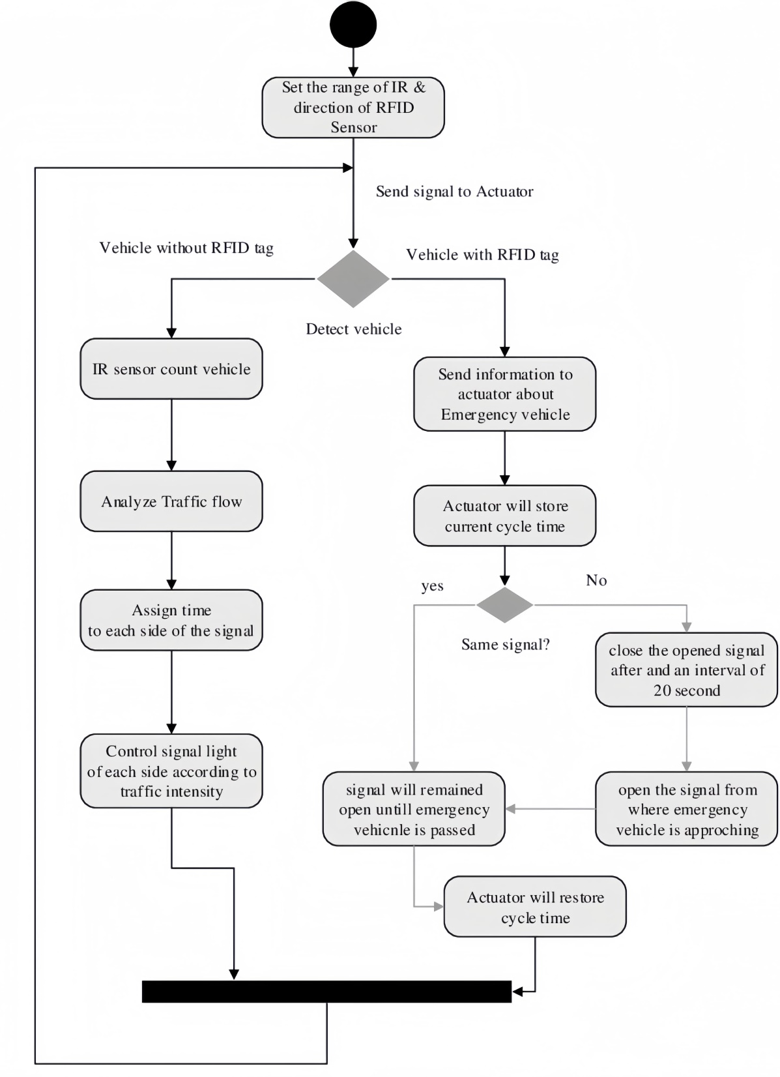

**Class diagram:**

A class diagram is a type of diagram in the Unified Modelling Language (UML) that represents the structure and relationships of a system's classes or objects. It provides a static view of the system, emphasizing the classes in the system and their associations, attributes, and operations.

Class diagrams are essential for modelling the static structure of a system and are widely used during the design and analysis phases of software development. They provide a visual representation of the system's architecture, helping developers, designers, and stakeholders understand the organization of classes and their relationships in the software system.

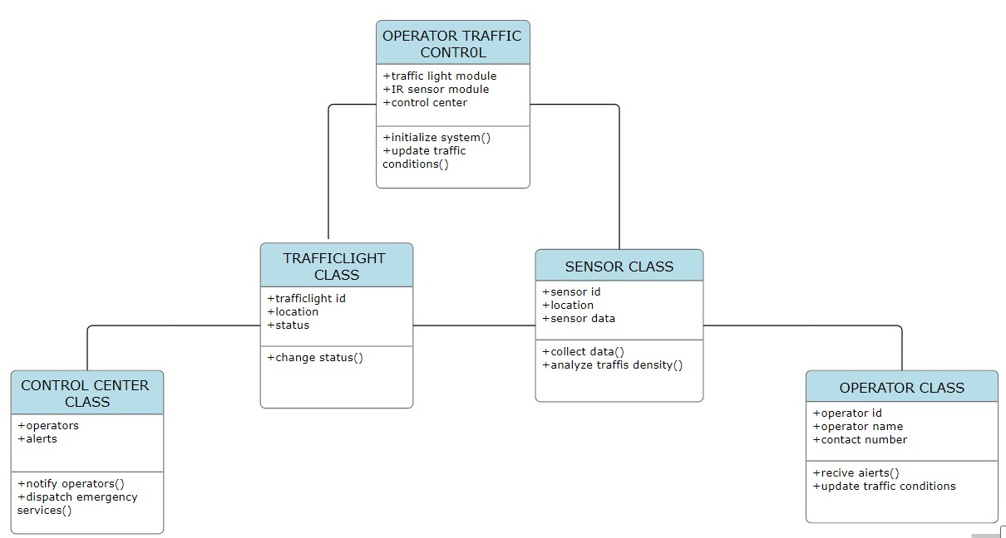**6. APPLICATIONS**

**6.1 Detection and Management of traffic Congestion**

In addition to the above discussed method of traffic congestion detection, another way of approach can be used. We can receive certain crucial data calculated by the Controller of the signals by creating and maintaining a server. The main aim is to implement a system that would track the travel time of individual cars as they pass the roadside controllers and calculate an average trip time using a systematic approach to decide whether the area is congested or uncongested. If congestion is sensed then system would control traffic signals / generate automatic alternative routing messages to selected approaching vehicles.

**6.2 Automatic detection of speed limit Violation**

This technique can be used to sense/detect the speed of vehicle, whether it violates the speed limit or not. If the vehicle violates the rule, a warning message will be sent to the vehicle via audio and/or video interface to their mobile and penalty will be calculated in the server and billed monthly to the owner of vehicle.

**6.3 Automatic Billing of Core Area / Toll Charges**

Automatic toll collection and automatic core area charge collections are also done using the same framework. Controller unit will be placed at toll-booth and along the motor able roads around the core area which will detect each individual vehicle uniquely within its zone by capturing their device id’s and will keep records of the time during which the vehicle was seen by those controllers within its reading zone. This information will be sent to a main server. Accordingly, the main server will calculate the charges and raise bills against the vehicle id’s.

**7. IMPLEMENTATION**

**Code in Embedded C language:**

const int sensorNorth = A0; // IR sensor input for the north road

const int sensorSouth = A1; // IR sensor input for the south road

const int sensorEast = A2; // IR sensor input for the east road

const int sensorWest = A3; // IR sensor input for the west road

const int redNorth = 6; // Red LED for the north road

const int greenNorth = 7; // Green LED for the north road

const int redSouth = 8; // Red LED for the south road

const int greenSouth = 9; // Green LED for the south road

const int redEast = 10; // Red LED for the east road

const int greenEast = 11; // Green LED for the east road

const int redWest = 12; // Red LED for the west road

const int greenWest = 13; // Green LED for the west road

const int yellowNorth=2;

const int yellowSouth=3;

const int yellowEast=4;

const int yellowWest=5;

bool northOccupied = false;

bool southOccupied = false;

bool eastOccupied = false;

bool westOccupied = false;

void setup() {

pinMode(sensorNorth, INPUT);

pinMode(sensorSouth, INPUT);

pinMode(sensorEast, INPUT);

pinMode(sensorWest, INPUT);

pinMode(redNorth, OUTPUT);

pinMode(greenNorth, OUTPUT);

pinMode(redSouth, OUTPUT);

pinMode(greenSouth, OUTPUT);

pinMode(redEast, OUTPUT);

pinMode(greenEast, OUTPUT);

pinMode(redWest, OUTPUT);

pinMode(greenWest, OUTPUT);

pinMode(yellowNorth, OUTPUT);

pinMode(yellowSouth, OUTPUT);

pinMode(yellowEast, OUTPUT);

pinMode(yellowWest, OUTPUT);

}

void loop() {

// Read sensor inputs

northOccupied = digitalRead(sensorNorth) == LOW;

southOccupied = digitalRead(sensorSouth) == LOW;

eastOccupied = digitalRead(sensorEast) == LOW;

westOccupied = digitalRead(sensorWest) == LOW;

// Traffic signal control logic

if (northOccupied && !southOccupied && !eastOccupied && !westOccupied) {

// Only north road has traffic

digitalWrite(greenNorth, HIGH);

digitalWrite(redNorth, LOW);

digitalWrite(greenSouth, LOW);

digitalWrite(redSouth, HIGH);

digitalWrite(greenEast, LOW);

digitalWrite(redEast, HIGH);

digitalWrite(greenWest, LOW);

digitalWrite(redWest, HIGH);

digitalWrite(yellowNorth, LOW);

digitalWrite(yellowSouth, LOW);

digitalWrite(yellowEast, LOW);

digitalWrite(yellowWest, LOW);

} else if (!northOccupied && southOccupied && !eastOccupied && !westOccupied) {

// Only south road has traffic

// (Similar logic for other directions)

digitalWrite(greenNorth, LOW);

digitalWrite(redNorth, HIGH);

digitalWrite(greenSouth, HIGH);

digitalWrite(redSouth, LOW);

digitalWrite(greenEast, LOW);

digitalWrite(redEast, HIGH);

digitalWrite(greenWest, LOW);

digitalWrite(redWest, HIGH);

digitalWrite(yellowNorth, LOW);

digitalWrite(yellowSouth, LOW);

digitalWrite(yellowEast, LOW);

digitalWrite(yellowWest, LOW);

}else if (!northOccupied && !southOccupied && eastOccupied && !westOccupied) {

// Only east road has traffic

// (Similar logic for other directions)

digitalWrite(greenNorth, LOW);

digitalWrite(redNorth, HIGH);

digitalWrite(greenSouth, LOW);

digitalWrite(redSouth, HIGH);

digitalWrite(greenEast, HIGH);

digitalWrite(redEast, LOW);

digitalWrite(greenWest, LOW);

digitalWrite(redWest, HIGH);

digitalWrite(yellowNorth, LOW);

digitalWrite(yellowSouth, LOW);

digitalWrite(yellowEast, LOW);

digitalWrite(yellowWest, LOW);

} else if (!northOccupied && !southOccupied && !eastOccupied && westOccupied) {

// Only WEST road has traffic

// (Similar logic for other directions)

digitalWrite(greenNorth, LOW);

digitalWrite(redNorth, HIGH);

digitalWrite(greenSouth, LOW);

digitalWrite(redSouth, HIGH);

digitalWrite(greenEast, LOW);

digitalWrite(redEast, HIGH);

digitalWrite(greenWest, HIGH);

digitalWrite(redWest, LOW);

digitalWrite(yellowNorth, LOW);

digitalWrite(yellowSouth, LOW);

digitalWrite(yellowEast, LOW);

digitalWrite(yellowWest, LOW);

}else if (!northOccupied && !southOccupied && !eastOccupied && !westOccupied) {

// No traffic on any road, flash yellow on all roads

// (Similar logic for other directions)

digitalWrite(yellowNorth,HIGH);

digitalWrite(yellowSouth,HIGH);

digitalWrite(yellowEast,HIGH);

digitalWrite(yellowWest,HIGH);

digitalWrite(redNorth,LOW);

digitalWrite(redSouth,LOW);

digitalWrite(redEast,LOW);

digitalWrite(redWest,LOW);

digitalWrite(greenNorth, LOW);

digitalWrite(greenSouth, LOW);

digitalWrite(greenEast, LOW);

digitalWrite(greenWest, LOW);

} else {

// Intersection is busy, all red

//digitalWrite(greenNorth, LOW);

//digitalWrite(redNorth, HIGH);

//digitalWrite(greenSouth, LOW);

//digitalWrite(redSouth, HIGH);

//digitalWrite(greenEast, LOW);

//digitalWrite(redEast, HIGH);

//digitalWrite(greenWest, LOW);

//digitalWrite(redWest,HIGH);

//digitalWrite(yellowNorth, LOW);

//digitalWrite(yellowSouth, LOW);

//digitalWrite(yellowEast, LOW);

//digitalWrite(yellowWest, LOW);

digitalWrite(redNorth,LOW);

digitalWrite(greenNorth,HIGH);

digitalWrite(yellowNorth,LOW);

digitalWrite(redSouth,HIGH);

digitalWrite(greenSouth,LOW);

digitalWrite(yellowSouth,LOW);

digitalWrite(redEast,HIGH);

digitalWrite(redWest,HIGH);

digitalWrite(greenWest,LOW);

digitalWrite(greenEast,LOW);

digitalWrite(yellowEast,LOW);

digitalWrite(yellowWest,LOW);

delay(10000);

digitalWrite(redSouth,LOW);

digitalWrite(yellowSouth,LOW);

digitalWrite(greenSouth,HIGH);

digitalWrite(redEast,HIGH);

digitalWrite(redWest,HIGH);

digitalWrite(greenWest,LOW);

digitalWrite(greenEast,LOW);

digitalWrite(yellowEast,LOW);

digitalWrite(yellowWest,LOW);

digitalWrite(redNorth,HIGH);

digitalWrite(greenNorth,LOW);

digitalWrite(yellowNorth,LOW);

delay(10000);

digitalWrite(redEast,LOW);

digitalWrite(yellowEast,LOW);

digitalWrite(greenEast,HIGH);

digitalWrite(redNorth,HIGH);

digitalWrite(greenNorth,LOW);

digitalWrite(yellowNorth,LOW);

digitalWrite(redSouth,HIGH);

digitalWrite(greenSouth,LOW);

digitalWrite(yellowSouth,LOW);

digitalWrite(redWest,HIGH);

digitalWrite(greenWest,LOW);

digitalWrite(yellowWest,LOW);

delay(10000);

digitalWrite(redWest,LOW);

digitalWrite(yellowWest,LOW);

digitalWrite(greenWest,HIGH);

digitalWrite(redNorth,HIGH);

digitalWrite(greenNorth,LOW);

digitalWrite(yellowNorth,LOW);

digitalWrite(redSouth,HIGH);

digitalWrite(greenSouth,LOW);

digitalWrite(yellowSouth,LOW);

digitalWrite(redEast,HIGH);

digitalWrite(greenEast,LOW);

digitalWrite(yellowEast,LOW);

delay(10000);

}}

**8. RESULTS & DISCUSSION**

The existing traffic management system followed time-based mechanism to control the traffic congestion on roads. A fixed amount of time is set in the traffic signal lights, according to which the signals change. For example, consider there are four signals at a junction each signal has already to fixed amount of time. The first signal shows green for 60 sec and remaining three signals will be red. After 60 sec the first signal turns red and second signal turns green. Other two remains same. After next 60 sec it’s third signal which turns green and remaining stays red. Hence in this system there is no chance of clearing traffic jam based on traffic density. As it is time taking and also waste of time, a prototype was developed to demonstrate the applicability of our proposed system.

Several experiments on real traffic data were made to evaluate the efficiency of the proposed algorithm. The traffic density was monitored and calculated by vehicle detection. As soon as the traffic density crosses the specified threshold on a road, the system stopped the normal operation and kept the green light on till the situation on the road became normal. The real-time data was also being sent to the local and central server as well. Besides this, a web interface was also developed for the authorities to show them the statistics of traffic on the roads so that they could make real-time and future decisions as discussed earlier. Figure 3 shows the statistical traffic data, i.e. number of vehicles passed in a particular time span at a particular road. The bar graph is representing real-time traffic data. Different bar graphs based on historical and real-time data are being drawn in this application which is helpful for traffic department and other related authorities for managing traffic congestions on roads and future planning.

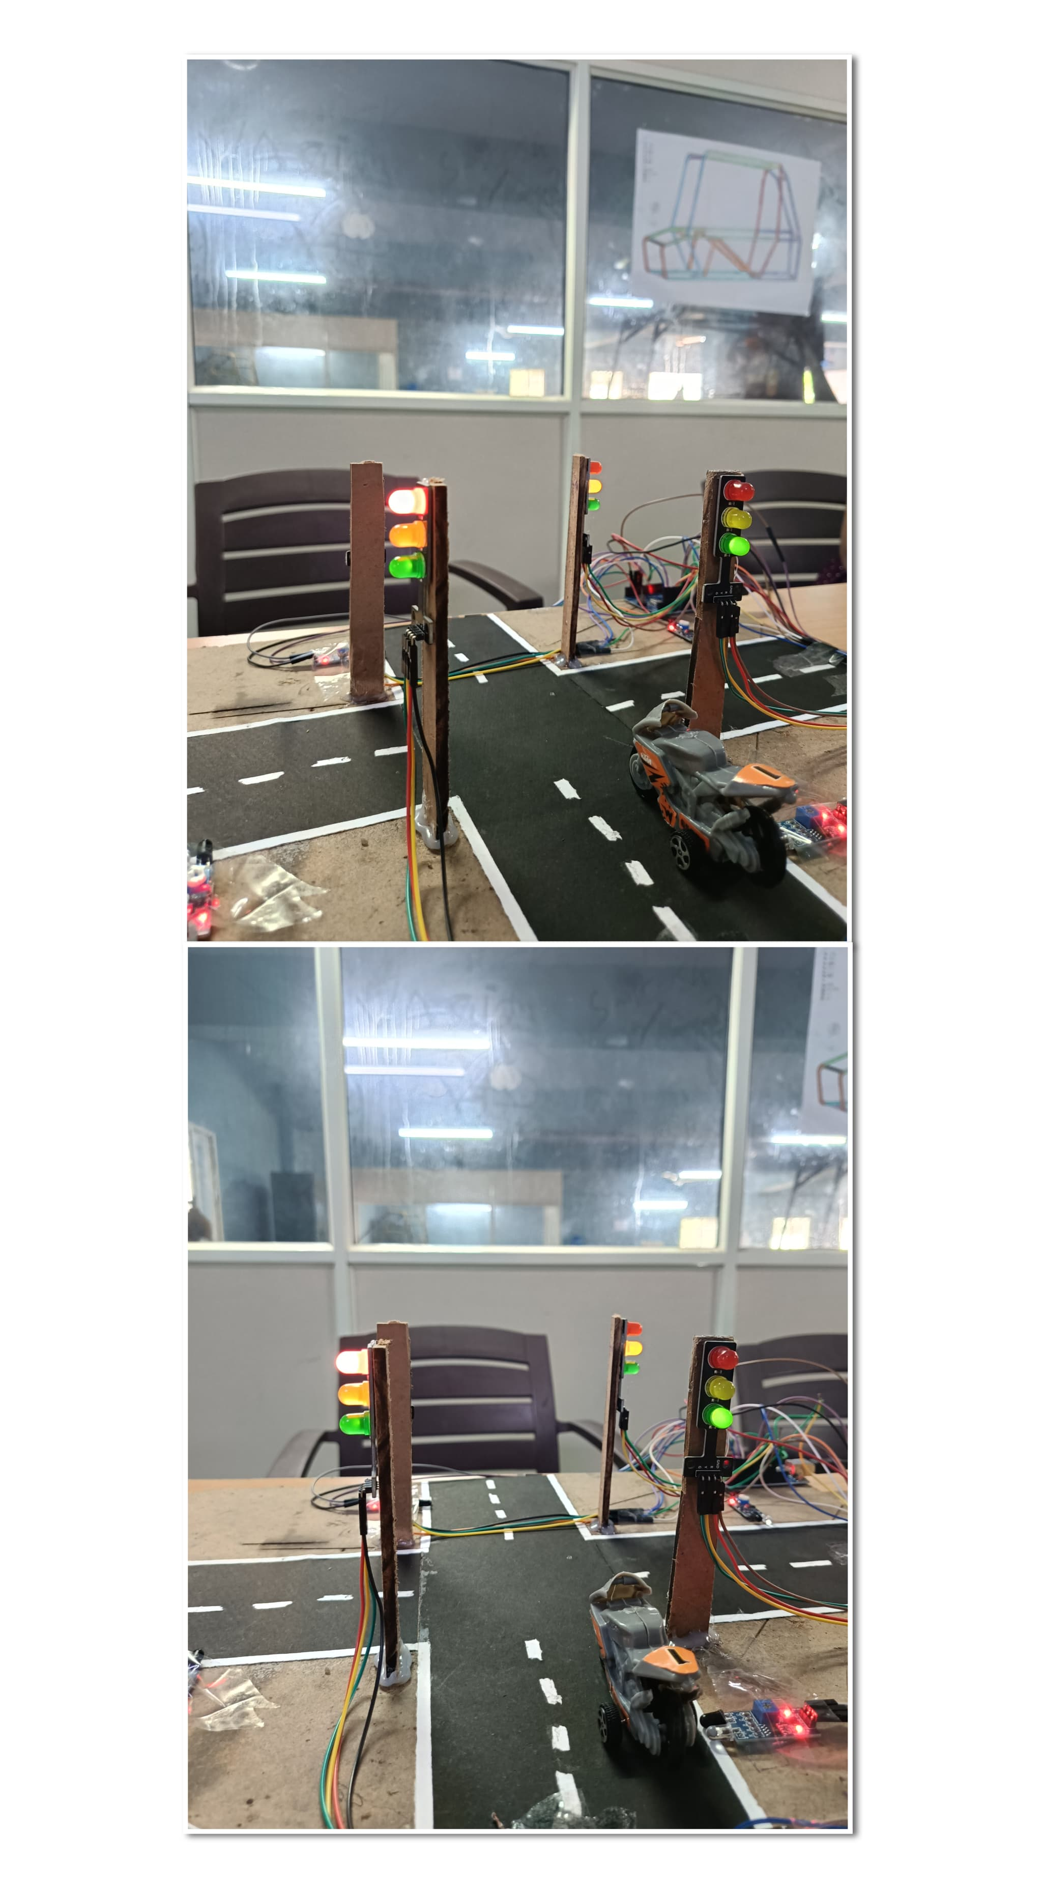

**Figure 8.1.** *Statistical data on traffic*

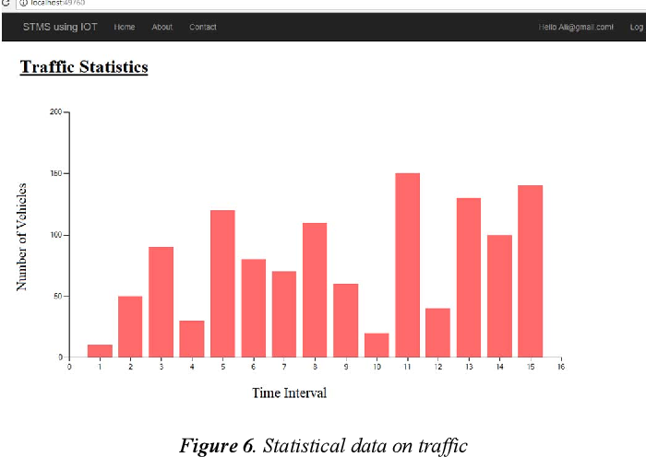

**9. CONCLUSION AND FUTURE WORK**

This research gives an optimal and effective solution for rapid growth of traffic flow particularly in metropolitan cities where they fail to manage current traffic effectively. Keeping this in view, a smart traffic management system is proposed to control road traffic situations more efficiently and effectively. It changes the timing of signal according to traffic density on the particular place and regulates traffic flow by communicating with local server more effectively than before. The decentralized approach makes it optimized and effective as the system works even if a local server or centralized server has network issues or may be a crash. The centralized server communicates with the nearest rescue department in case of any emergency situation which provides more safety. Moreover, a user can ask about future traffic level at particular road hence avoiding wastage of time in traffic jams. The system also provides useful information to higher authorities that can be used in road planning which helps in optimal usage of resources.

Furthermore, the study presents the problems in metropolitan areas all over the world caused by congestions and the related sources. Congestions developed to a problem, which affects economies worldwide. Particularly metropolitan areas are worst hit under these conditions. Congestions have a negative impact on the financial situation of a country, on the environment and hence the overall quality of life. The proposed system can be enhanced by using any other powerful communication network other than GSM.

**REFERENCES**

[1] W. S. Associate, "Transportation and Economy Report," MDOT State Long­ Range Transportation Plan, Karachi, 2007.

[2] K. S. D. M. R. B. Patan Rizwan, "Real-Time Smart Traffic Management System for Smart Cities by Using Internet of Things and Big Data," in International Conference on Emerging Technological Trends [ICETT], Kollam, 2016.

[3] C. S. D. L. T. Authority, "Annual Vehicle Statistics," Annual Vehicle Statistics 2015, Karachi, 2015.

[4] M. P. a. B. B. Sivasankar, "IoT Based Traffic Monitoring using Raspberry Pi," International Journal of Research in Engineering, Science and Technology (IJRESTs), vol. 1, no. 7, pp. 2454-664x, 2016.

[5] A. Lone, "Karachi’s crime malaise," Tribune.com.pk, 18 August 2011. [Online]. Available: https://blogs.tribune.com.pk/story/7540/karachiscrime-malaise/. [Accessed 20 September 2017].

[6] S. Sharief, "Road Accidents in Pakistan Reach Alarming High: Who’s Responsible," Pakwheels.com, 2016. [Online]. Available: https://www.pakwheels.com/blog/alarming-increase-of-road-accidentsin-pakistan/. [Accessed 2017].

[7] B. k. Khan, "Traffic jams in Karachi result in losses worth of millions each day," PakWheels.com, 2013. [Online]. Available: https://www.pakwheels.com/blog/traffic-jams-karachi-result-lossesworth-millions-day/. [Accessed 2017].

[8] P. K. K. P. S. T. Prashant Jadhav, "Smart Traffic Control System Using Image Processing," International Research Journal of Engineering and Technology (IRJET), vol. 3, no. 3, pp. 2395-0056, 2016.

[9] E. Leigh, "Advancing integrated and sustainable transport for the Cambridge region," Smarter Cambridge Transport, 2017. [Online]. Available: http://www.smartertransport.uk/. [Accessed 2017].

[10] T. C. N. K. Kartikeya Jain, "Smart vehicle identification system using OCR," in 3rd International Conference on Computational Intelligence & Communication Technology (IEEE-CICT 2017), Ghaziabad, India, 2017.

[11] T. e. a. Osman, "Intelligent traffic management system for a cross section of roads using computer vision," in Computing and Communication Workshop and Conference (CCWC), 2017 IEEE 7th Annual, 2017.

[12] D. C. J. E. J. Khac-Hoai Nam Bui, "Real-Time Traffic Flow Management Based on Inter-Object Communication: a Case Study at Intersection," in 7th International Conference on Ambient Intelligence (ISAmI’2016), 2016.

[13] V. S. A. M. S. D. K. K. Swathi, "Traffic Density Control and Accident Indicator Using WSN," International Journal for Modern Trends in Science and Technology, vol. 2, no. 4, pp. 2455-3778, 2016.

[14] H. O. Al-Sakran, "Intelligent traffic information system based on the integration of Internet of Things and Agent technology," International Journal of Advanced Computer Science and Applications (IJACSA), vol. 6, no. 2, pp. 37-43, 2015.

[15] A. S. Nidhi D. Agrawal, "Intelligent Real Time Traffic Controller Using Image Processing – A Survey," International Journal of Science and Research (IJSR) ISSN (Online), vol. 4, no. 4, pp. 2319-7064, 2015.

[16] J. D. D. M. A. M. A. J. Vismay Pandit, "Smart Traffic Control System Using Image Processing," International Journal of Emerging Trends & Technology in Computer Science (IJETTCS), vol. 3, no. 1, pp. 2278- 6856, 2014.

[17] D. S. P. S. Y. M. Pranav Maheshwari, "Smart Traffic Optimization," in 3rd International Conference on MOOCs, Innovation and Technology in Education (MITE), IEEE, 2015.

[18] M. A. M. A. T. R. J. S. A.-M. A. B. Fozia Mehboob, "Automated Vehicle Density Estimation from Raw Surveillance Videos," in SAI Computing Conference 2016, London, 2016.

[19] K. B. M. R. M. B. Shubham N. Mahalank, Device to Device Interaction Analysis in IoT based Smart Traffic Management System: An Experimental Approach, Symposium on Colossal Data Analysis and Networking (CDAN), 2016.